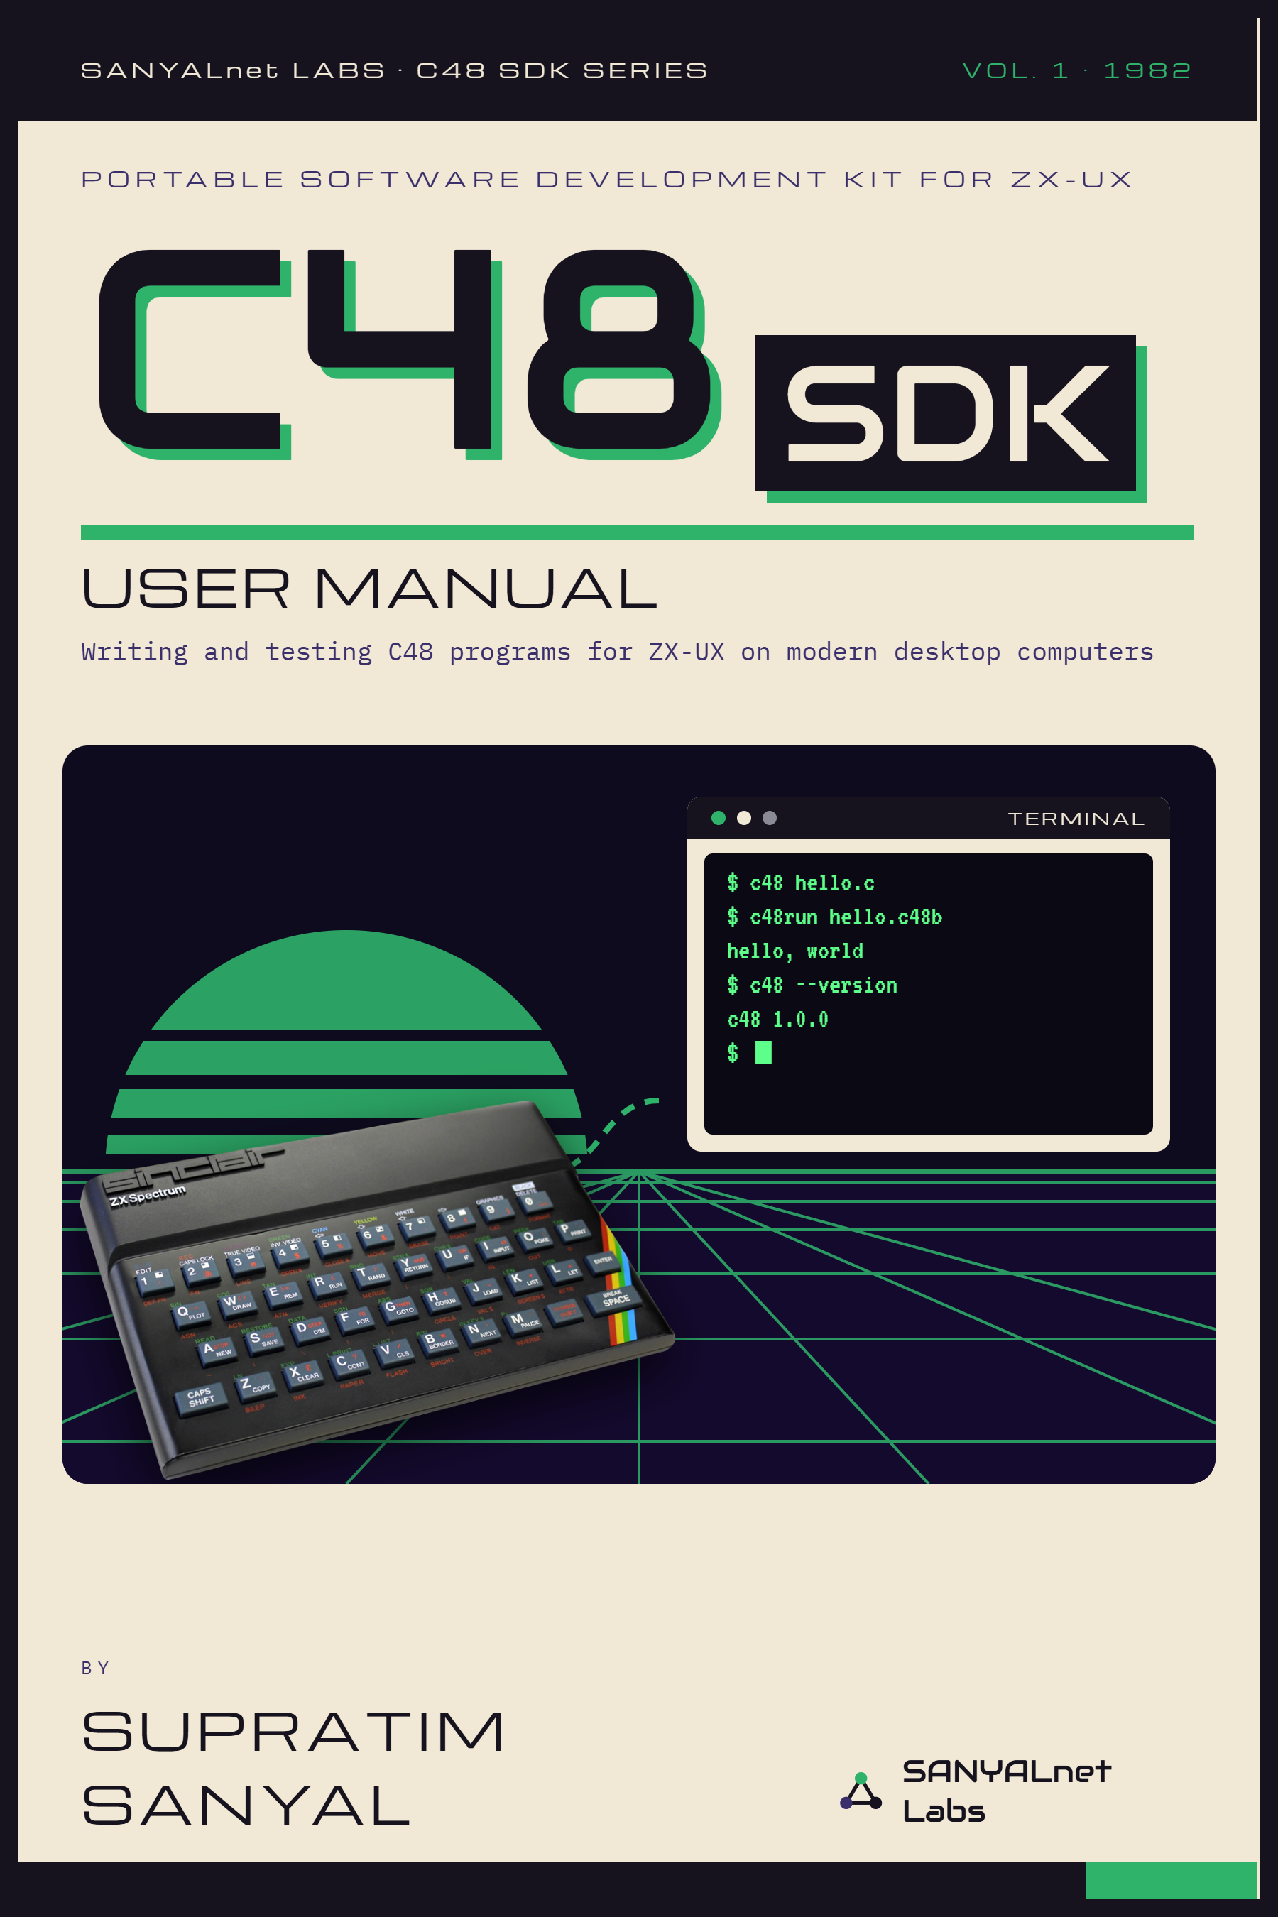

ZX-UX C48 SDK
USER MANUAL & DEVELOPER'S GUIDE
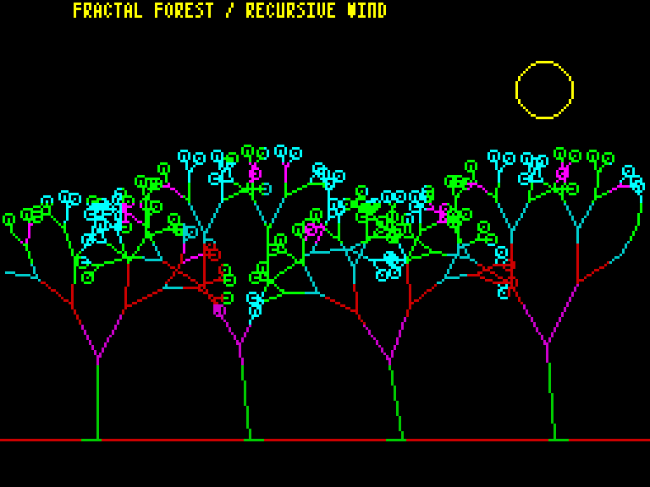
Portable C48 compiler and development runtime for ZX-UX Unix
for Sinclair ZX Spectrum 48K
Supratim Sanyal / SANYALnet Labs
https://supratim-sanyal.blogspot.com/
SDK 1.0.0 | September 2026

Publication Notice
Copyright (c) 2026 Supratim Sanyal of SANYALnet Labs. This document is governed by the SANYALnet Labs Non-Commercial License in the repository root LICENSE file. The required attribution is “Based on original work by Supratim Sanyal of SANYALnet Labs.”
This manual is the practical guide to the ZX-UX C48 SDK. The SDK runs on modern hosts, but it is for C48 programs meant for ZX-UX Unix on a Sinclair ZX Spectrum 48K. We cover setup, compiling, running, the Spectrum screen and memory map, shipped software, and the line between host tests and native behavior. Exact language rules live in the C48 Language Specification and the C48 Compiler User Manual. Filing cabinets may relax.
Read this boundary first
The host SDK compiles C48 source into deterministic C48B1 host executables and runs them in a logical C48 virtual machine. C48B1 is not Z80 machine code, OBJ1, or MEX1. The host VM is not a cycle-accurate ZX Spectrum or ZX-UX machine emulator, and it does not provide a host multi-object linker.
C48 syntax and semantics come from the C48 Language Specification Rev 0.11. The native memory map, process model, file formats, and runtime rules come from ZX-UX Architecture Rev 12. Host commands come from the shipped SDK code and the SDK Technical Reference. The C48 Compiler User Manual gives deeper compiler detail. When host behavior differs from native ZX-UX, we say so.

How to Use This Manual
Start with Part I if this is a new SDK checkout.
Use Part II when compiling C48 source or checking the 48K data model.
Use Part III when running programs, capturing screens, or diagnosing display, input, math, timing, and sound.
Use Part IV for the host API profile, shipped apps/games/demos, verification, and portability boundaries.
Keep the C48 Compiler User Manual nearby when exact syntax, diagnostics, or unsupported language features matter.

Contents
Section | Subject
PART I | Host Environment & Toolchain Setup
1 | From Modern Host to the C48 Target Model
2 | Installation and First Verification
PART II | The C48 Host Toolchain
3 | Compiling with c48
4 | C48 Data and the ZX-UX Memory Map
5 | C48 Language Working Rules
PART III | Runtime, Display, Input, Math, and Sound
6 | Running with c48run
7 | Spectrum Display and Keyboard Behavior
8 | Timing, Float5, and BEEP
PART IV | Host API, Shipped Software, Verification, and Portability
9 | The SDK Host API Profile
10 | Included Software
11 | Verification and Hostile-Input Safety
12 | The Native ZX-UX Boundary
13 | Worked Example: Fractal Forest
14 | Troubleshooting
APPENDIX A | Quick Command Card
APPENDIX B | Specifications and Feature Card
APPENDIX C | Fractal Forest Source Listing
APPENDIX D | Documentation and Links

PART I
HOST ENVIRONMENT & TOOLCHAIN SETUP
A modern Python host supplies the tools. ZX-UX on the original 48K Spectrum supplies the target contract.

1. From Modern Host to the C48 Target Model
The SDK lets us write and test C48 on Windows, Linux, and macOS for ZX-UX Unix on the original Sinclair ZX Spectrum 48K. The host compiler keeps the C48 language data model. c48run models the target-facing memory range, screen, console, Float5, and selected runtime services. C48B1 and c48run remain host tools; native ZX-UX runs Z80 executables and kernel services.
MODERN HOST FILESYSTEM
C48 source (.c)
|
v
+-----------+ deterministic +----------------+
| c48 | ----------------------> | C48B1 host exe |
+-----------+ +----------------+
|
v
+-------------+
| c48run |
| logical VM |
+-------------+
| |
Tk 256x192 headless
final frame .scr dump
The important word in that diagram is logical. The host runtime models C48 values, memory, pointer life, exact Spectrum screen bytes, and selected services. It does not run Z80 instructions. It does not model ULA contention, raster timing, or a booted ZX-UX kernel. Calling it cycle-accurate would be memorable and wrong.

1.1 SDK component inventory
Component | What it does
c48 / c48.bat | Compiles one C48 translation unit into deterministic C48B1 host executable form.
c48run / c48run.bat | Runs C48B1 in the logical 16-bit C48 VM, either with the Tk display or headlessly.
usr/src/ | Shipped C48 source tree: ailmzx48, apps, demos, examples, games, security, sound, plus c48host.h.
usr/bin/ | Matching compiled C48B1 deliverables for ailmzx48, apps, demos, examples, games, security, and sound. These are shipped programs and should be retained with the SDK.
usr/src/c48host.h | SDK host header for console, memory, graphics, UDG, heap, selected math, and related development services.
compiler/verify_release.py | Runs the SDK verification suite, including deterministic rebuild and validation checks.

1.2 What the host SDK does not pretend to be
It is not the native ZX-UX cc/ld toolchain and does not emit OBJ1 or MEX1.
It is not a host linker for several C48B1 files. The 1.0.0 host SDK compiles and executes one translation unit at a time.
It is not a Z80 register debugger or a GDB-style remote target.
It is not a virtual-disk editor or a ZX-UX filesystem image injector.
It is not a cycle-accurate Spectrum, ULA, scheduler, pipe, cassette, or kernel-system-call emulator.
It does not turn SDK-local headers into the native ZX-UX <c48.h> interface.
Why this distinction helps
A strict boundary makes host results useful. C48 source behavior can be checked now without quietly inventing native facilities that later have to be un-invented. The 48K machine already has enough constraints; fictional ones need not join it.

1.3 Which document controls which question
Host commands and VM behavior come from the shipped SDK code. C48 language rules come from the C48 Language Specification Rev 0.11. Native ZX-UX rules come from ZX-UX Architecture Rev 12. That includes the memory map, process model, OBJ1/MEX1, calling convention, and kernel services. If a host convenience differs, it stays a host convenience.
Portability rule
ZX-UX is the target contract. C48B1, Tk windows, PPM export, execution quotas, and other launcher features are host development tools around the program. C48 source should not depend on them. The host VM also adds stricter diagnostics, such as pointer-provenance checks; those diagnostics help find bugs but do not describe new Spectrum hardware.

2. Installation and First Verification
The SDK is deliberately light on host dependencies. We need Python 3.10 or newer. Windows expects the command name python on PATH; Linux and macOS use python3. Tkinter is needed only for the graphical display window.
The compiler and non-audio headless runtime need no third-party Python package. On Windows, audible BEEP playback uses the Python standard-library winsound backend. On Linux and macOS, audible playback can use the optional playsound3==3.3.2 adapter. Sound is optional; silence is an acceptable host condition, which is a rare sentence in a software manual and a perfectly useful one here.

2.1 Get the SDK
git clone https://github.com/tuklusan/zx-ux-c48-sdk-sinclair-zx-spectrum-48k-unix-c-compiler-software-development-kit.git
cd zx-ux-c48-sdk-sinclair-zx-spectrum-48k-unix-c-compiler-software-development-kit
No SDK-specific shell environment variables are documented as required. The practical requirement is simpler: run from the checkout, and make sure the appropriate Python command is on PATH. We do not add mystery variables merely because a section title looks lonely without them.

2.2 Verify the launchers
Host | Commands
Windows | c48.bat --version  c48run.bat --version
Linux / macOS | ./c48 --version  ./c48run --version

2.3 Run the SDK verifier
Host | Command
Windows | python -B compiler\verify_release.py
Linux / macOS | python3 -B compiler/verify_release.py
The SDK verifier is much more than a "does it start?" check. It rebuilds and validates the shipped corpus, checks deterministic artifacts, exercises host/runtime tests and security fixtures, and runs the demo checks. Use it when validating a checkout. For ordinary edit-compile-run work, the version checks and a small compile are quicker.

2.4 A five-minute smoke test
Fractal Forest is a good first test. It compiles real recursive C48 code, draws in color, animates the screen, and uses the display path. It also needs no setup data. For a first run, fewer moving parts are a kindness.
Host | Compile | Run
Windows | c48.bat usr\src\demos\forest.c | c48run.bat usr\bin\demos\forest.c48b
Linux / macOS | ./c48 usr/src/demos/forest.c | ./c48run usr/bin/demos/forest.c48b
If the GUI is unavailable, run the same executable headlessly. The code still executes; the window simply stays out of the argument.
./c48run --headless usr/bin/demos/forest.c48b

PART II
THE C48 HOST TOOLCHAIN
Compile one C48 translation unit, keep the target data model fixed, and let the 48K assumptions remain visible instead of hiding them under a desktop ABI.

3. Compiling with c48
The host workflow is compile, then run. c48 reads C48 source and emits C48B1. There is no host linking stage after that for SDK 1.0.0, because C48B1 is the executable host artifact for one translation unit.

3.1 Default output placement
Sources under usr/src/ compile by default into the matching path under usr/bin/. A source at usr/src/demos/forest.c therefore maps to usr/bin/demos/forest.c48b. Sources elsewhere compile beside the source with a .c48b suffix unless an explicit output path is supplied.
usr/src/demos/forest.c
|
| c48
v
usr/bin/demos/forest.c48b
other/place/example.c
|
| c48
v
other/place/example.c48b

3.2 Everyday compile commands
Task | Windows | Linux / macOS
Check compiler version | c48.bat --version | ./c48 --version
Show compiler/about text | c48.bat --about | ./c48 --about
Compile shipped source | c48.bat usr\src\demos\forest.c | ./c48 usr/src/demos/forest.c
Choose output path | c48.bat source.c -o out.c48b | ./c48 source.c -o out.c48b
No imaginary build switches
The supplied SDK manuals do not define optimization levels, assembly-output switches, command-line macro definitions, or a host linker command for c48. This manual therefore does not manufacture them. Exact language and compiler behavior belongs in the C48 Compiler User Manual.

3.3 What C48B1 contains
C48B1 is the host executable format. Its reader checks the magic, SHA-256 integrity field, ASCII JSON payload, schema, and canonical re-encoding before the VM starts. Size and depth limits guard the reader against hostile files. C48B1 is deterministic, but it is still host plumbing rather than Z80 code.
C48B1 is separate from native ZX-UX files. The native C48 toolchain uses OBJ1 modules and MEX1 executables. The host compiler writes C48B1 for c48run. The C source can be the same even though the plumbing is not.

3.4 One translation unit at a time
The host SDK accepts compatible extern declarations. That lets source stay ready for native multi-module linkage. The host does not resolve a C48 function or object from another C48B1 file. A needed external definition must be in the same translation unit or be a documented host builtin. Otherwise host execution fails, instead of rummaging through nearby binaries.

3.5 Quoted includes
Quoted includes use an exact-case portable basename in the same directory. Host .c, .h, and .txt files stand in for native TXT/C include objects. Ordinary Windows, Linux, and macOS files do not carry ZX-UX object-type metadata, so the suffix has to do some honest work.
When source is untrusted
A quoted include can read an allowed sibling .c, .h, or .txt file in the source directory. For multi-user or service-style compilation, place the submission and only its approved includes in an isolated temporary directory. The compiler is a development tool, not a magical secrecy field around whatever happens to sit beside the source file.

4. C48 Data and the ZX-UX Memory Map
C48 keeps its data model fixed even when the host CPU is 64-bit and feeling rather pleased with itself. Observable C48 values use the widths required by the Spectrum-oriented language, not the widths preferred by the desktop ABI.

4.1 Scalar size and alignment
C48 type | Size | Alignment
char | 1 byte | 1
unsigned char | 1 byte | 1
short | 2 bytes | 2
unsigned short | 2 bytes | 2
int | 2 bytes | 2
unsigned int | 2 bytes | 2
pointer | 2 bytes | 2
float | 5 bytes | 1
Plain char is unsigned. Sixteen-bit integers and pointer objects use little-endian storage. C48 float uses the five-byte Spectrum numeric representation rather than IEEE binary32. An int is therefore 16 bits because the language says so, not because the host has suffered a sudden loss of ambition.

4.2 16-bit pointers do not mean 64 KiB of program RAM
C48 pointers are 16-bit target addresses. They can carry values from 0x0000 through 0xFFFF, but the original Spectrum has only 49,152 bytes of RAM, at 0x4000 through 0xFFFF. ZX-UX uses 6,912 bytes for the screen, 1,280 bytes for ROM-compatibility workspace, and 8,192 bytes for the resident kernel. That leaves the 32,768-byte shared task/object arena at 0x6000 through 0xDFFF for ordinary C48 program and object storage.
The host SDK uses the same general-allocation range. Globals, automatic objects, strings, argv data, and host heap blocks are allocated only in 0x6000 through 0xDFFF. Screen bytes are mapped separately at 0x4000 through 0x5AFF. The VM keeps a 65,536-byte backing array so every 16-bit address has a slot; that backing array is an address model, not program RAM.
Region | Bytes | ZX-UX use | General C allocation
0x0000-0x3FFF | 16,384 | Spectrum ROM | No
0x4000-0x57FF | 6,144 | Screen bitmap | No - screen services
0x5800-0x5AFF | 768 | Screen attributes | No - screen services
0x5B00-0x5FFF | 1,280 | ROM compatibility/workspace | No
0x6000-0x7FFF | 8,192 | COLD/CONTENDED task/object arena | Yes
0x8000-0xDFFF | 24,576 | FAST task/object arena | Yes
0xE000-0xFFFF | 8,192 | Resident ZX-UX kernel | No
The native 32,768-byte arena is shared by process images, BSS, C48 heaps, process stacks, ARG1/ENV1 blocks, RAM objects, pipes, and pinned system data. The normal pinned font, UDG bank, and command catalog use 392 + 256 + 488 = 1,136 bytes. Subtracting those leaves 31,632 bytes before the shell process, its stack and bootstrap data, other resident objects, pipes, or the program itself are counted. There is therefore no single fixed “C48 free memory” figure after boot.
The SDK matches the native allocation range, but it does not reproduce native byte-for-byte occupancy. C48B1 code and Python call frames live outside the logical arena; native Z80 image/BSS and the process stack live inside it. The host also does not keep the shell, pipes, or the normal pinned ZX-UX resources resident. Host success therefore does not by itself certify that a program fits native RAM. The last host byte remains a poor souvenir.

4.3 Heap
By default, c48run permits at most 1,024 simultaneously live bytes obtained through malloc(). The --heap option accepts even values from 0 through 8,192. Native ZX-UX accounts for the same default number differently: crt0 reserves a fixed 1,024-byte heap inside BSS at link time, whether or not every byte is later allocated. The byte count matches; the memory accounting does not.
Raise the host-development heap ceiling to 2048 bytes with:
./c48run --heap 2048 usr/bin/demos/forest.c48b

4.4 Pointer and lifetime checks
The host VM checks memory mistakes that would be dangerous on shared Spectrum RAM. It diagnoses null, dead, out-of-range, misaligned, one-past, stale automatic, and invalid-free cases. On bare hardware, such mistakes are less polite.
A pointer carries more than a 16-bit number in the host VM. It also keeps its allocation identity. A stale pointer stays stale even if new storage later gets the same numeric address. Raw bytes copied into a pointer object do not gain valid provenance by coincidence. This blocks stale-pointer revival and byte-level pointer forgery.

4.5 Host safety ceilings are not new language rules
The host compiler and C48B1 reader put bounds on source size, token count, AST work, nesting, macro growth, JSON structure, type depth, VM call depth, and other host resources. These bounds protect the Python process from hostile input. They are host safety limits unless the C48 language or ZX-UX architecture states the same limit.
ZX-UX caps an ordinary RAM C or quoted-include object at 32,768 logical bytes. Other host safety limits stay host limits unless a C48 or ZX-UX rule says otherwise.

5. C48 Language Working Rules
This chapter is a field card, not another language specification. Use the C48 Language Specification for exact language rules. Use the C48 Compiler User Manual for compiler use and diagnostics. Duplicating a language standard in friendly prose is how friendly prose becomes an enemy.

5.1 The rules most likely to surprise a desktop C programmer
Plain char is 8-bit unsigned. int and short are 16-bit. Pointers are logically 16-bit.
float is the five-byte Spectrum representation and is materialized at C48 operation boundaries.
C48 supports one-dimensional arrays, direct functions, object pointers, locals, globals, file-scope static, and extern declarations.
Function pointers, pointer-to-array types, structs, unions, enums, long, double, variadic functions, switch, goto, compound assignment, ?:, and the comma expression are outside Version 1.
Object-like #define and constrained #include are supported. Full ISO preprocessing is not.
Identifiers are case-sensitive and may contain at most 15 visible characters.
Canonical C48 source bytes are printable ASCII plus TAB and LF. The host preprocessor may normalize complete CRLF pairs to LF; a stray CR, BOM, Unicode byte, or other control byte is rejected.
Function arguments and ordinary expression operands evaluate left-to-right under C48 rules.
C48 supports exactly the defined main forms: int main(void) and int main(int argc, char **argv).

5.2 A tiny C48 program
int main(void)
{
return 0;
}
A program needs no header when it uses no runtime service. The C48 language defines <c48.h> as the native system header. The standalone host c48 launcher does not populate that native declaration set, so shipped SDK programs use same-directory headers such as c48host.h, exapi.h, appapi.h, gameapi.h, and demoapi.h for the services used by each program. Those local headers are SDK packaging aids, not replacement ZX-UX system headers.

5.3 Write for the machine you actually have
Small functions, fixed-size data, bounded loops, compact strings, integer arithmetic where practical, and explicit error checks fit C48 well. Recursion consumes stack. Arrays consume RAM. Five-byte floating point is useful and heavier than simple integer work. The Spectrum has 48 KiB; it has no hidden cloud account under the rubber keyboard.

PART III
RUNTIME, DISPLAY, INPUT, MATH, AND SOUND
c48run executes the host artifact, maintains the logical C48 machine, and presents either a Tk Spectrum window or a deterministic headless result.

6. Running with c48run
c48run loads a validated C48B1 executable and runs it in the host VM. The default interactive path opens the Tk display when available. Headless mode is useful for automation, screen capture, CI, servers without a display, and anyone who would rather not negotiate window focus at two in the morning.

6.1 Verified runtime options used by this SDK
Option / operand | Use
--version | Print the runtime version and exit.
--about | Print SDK copyright/license information and exit.
program | Required C48B1 program path.
args ... | Optional C48 program arguments appended after argv[0].
--headless | Execute without the Tk graphical window.
--dump-screen PATH | Write the exact 6912-byte Spectrum screen state after execution.
--ppm PATH | Write a 256x192 paper-only binary PPM after execution.
--frame-ppm PATH | Write a 320x240 binary PPM including the Spectrum border.
--scale N | Request Tk integer scale 1..5; default 3. The GUI may choose a smaller scale if the desktop cannot fully map the requested window.
--font PATH | Use another valid F4X8 font resource instead of the default Tasword asset.
--heap BYTES | Set the host heap ceiling to an even value from 0 through 8192; default 1024.
--max-steps N | Deterministic VM step budget. Zero means unlimited; default 0.
--time-quota SECONDS | Wall-clock VM execution quota. Zero means unlimited; default 0.0.
--allow-approx-rom-math | Use host math followed by Float5 requantization instead of the default ROM-derived path; intended only as an explicit approximation fallback.

6.2 Program arguments
c48run passes the program operand itself as argv[0], followed by any extra args. The VM accepts 1 through 16 total argv entries, requires canonical ASCII with no NUL byte, and enforces the native-style 256-byte ARG1 envelope: eight header bytes plus all NUL-terminated argument strings must fit. A very long program path therefore counts too. Tiny machines remain admirably unimpressed by verbose directory names.

6.3 Common run forms
./c48run usr/bin/demos/forest.c48b
./c48run --headless usr/bin/demos/forest.c48b
./c48run --headless --dump-screen forest.scr usr/bin/demos/forest.c48b
./c48run --headless --ppm forest.ppm usr/bin/demos/forest.c48b
./c48run --headless --frame-ppm forest-frame.ppm usr/bin/demos/forest.c48b
./c48run --max-steps 10000 --time-quota 5 usr/bin/demos/forest.c48b
./c48run usr/bin/examples/argv.c48b alpha beta gamma

6.4 Deterministic screen and image capture
A screen dump is the raw 6912-byte Spectrum screen state. It is not a desktop screenshot. The bitmap and attributes can be hashed byte for byte without involving a window manager or monitor. --ppm renders the 256x192 paper area. --frame-ppm adds the border in a 320x240 image. These images are useful, but the .scr bytes remain the target screen record.

6.5 Execution budgets
Execution has no step or wall-clock quota when --max-steps and --time-quota are zero. Tests and hostile-input runs can set either limit, or both. The VM also caps user-function call depth at 64. Deep recursive C48 code then fails with a C48 runtime error instead of asking Python to discover the bottom of its own stack.

7. Spectrum Display and Keyboard Behavior

7.1 Display model
The display backing is the exact 6912-byte Spectrum layout: 6144 bitmap bytes and 768 attribute bytes. High-resolution graphics use the Spectrum bottom-left y convention. Physical bitmap rows used by tty64 and UDG storage are top-down. INK, PAPER, BRIGHT, FLASH, OVER, and INVERSE follow Spectrum terms.
The software text console is 64 columns by 24 rows using packed 4x8 F4X8 font data. The default host asset is the Tasword-style resource; --font selects another valid resource. The 64-column console and the 256x192 graphics surface share the same real screen backing rather than living in unrelated mock windows.

7.2 Deferred right-margin wrap
tty64 uses deferred wrap at the right margin. A printable byte written in column 63 remains there and sets a pending-wrap state. The next printable byte resolves the wrap. At the bottom row, that resolution scrolls exactly once. CR, LF, BS, TAB, and FF cancel pending wrap before performing their own operation; unsupported ignored controls leave the state alone.
This sounds fussy because right-margin behavior is fussy. Terminal code has been turning one-character edge cases into whole afternoons since long before any of us had enough RAM to resent it properly.

7.3 Keyboard input and BREAK
Host action | C48 behavior
Return | Maps to LF (0x0A) for getchar().
Backspace | Maps to byte 8.
Escape | Maps to byte 7, the portable-SDK host equivalent of CAPS+1 on a physical ZX Spectrum running native ZX-UX; it is not ASCII ESC (27).
Non-ASCII GUI text | Ignored.
Shift+Space while program is running | Acts as the Spectrum-style BREAK control and aborts the active GUI session with host status 130.
Shift+Space after program completion | Closes the held final frame without changing the completed program status.
BREAK is frontend control, not a getchar() byte. Normal GUI keystrokes are translated to C48 console bytes and placed in a bounded 256-byte FIFO; getchar() consumes them in order and waits when the queue is empty. Shift+Space bypasses that queue as BREAK. The SDK does not emulate the raw Spectrum keyboard matrix.

7.4 The footer is not screen memory
The Tk window shows a small host footer with the BREAK hint and a second subdued ZX-UX copyright line. Neither footer is written into Spectrum screen memory. A dumped .scr therefore contains only the target display state, exactly as it should.

8. Timing, Float5, and BEEP

8.1 Time and presentation
ticks() and sleep() in the SDK host API use host monotonic time with a 50 Hz interpretation. The GUI may present frames more slowly than that clock. yield() and animation sleep boundaries wait for the published frame to pass the Tk draw and host-visible presentation boundary, so intentional frames are not silently dropped just to catch up.
The host does not model the ZX-UX scheduler, process table, pipes, cassette I/O, or kernel calls. Its timing helpers are development services. They are not a tiny operating system hiding behind the curtain.

8.2 Float5 arithmetic
Every C48 float occupies exactly five bytes. Core arithmetic is kept in the C48 five-byte form at operation boundaries. The normal transcendental path follows the checked-in Sinclair 48K ROM calculator logic. The point is repeatable C48 behavior, not a quiet switch to desktop IEEE floats.
The SDK checks exact five-byte results for selected ROM-derived functions and edge cases. The default runtime uses that ROM-derived path. --allow-approx-rom-math instead uses host math and then converts back to Float5. Do not use that switch when ZX-UX-oriented numeric behavior matters.

8.3 Synchronous BEEP
The host API provides int beep(float duration, float pitch). The order matches Sinclair 48K BEEP: duration first, pitch second. The call is synchronous, so C48 execution waits until the requested tone ends. Even a beep gets to finish its sentence.
The host derives waveform timing from the 48K ROM BEEP reference and renders an 8-bit mono WAV. Literal beep() arguments can be synthesized when C48B1 is loaded; computed arguments are synthesized on first use and cached. Windows playback uses winsound. Linux and macOS can use playsound3==3.3.2 when installed. If a POSIX audio backend is absent, the shipped tune reports silent mode and completes rather than treating the missing speaker as a constitutional crisis.
What automated checks prove
Automated checks verify generated WAV timing, edge count, frequency, duration, and synchronous VM wall time. They do not claim that a physical speaker made a noise. Servers are allowed to be dull.

8.4 Runtime checklist
Question | Answer
Need a window? | Use normal c48run for Tk presentation; use --headless when no GUI is needed.
Need exact screen bytes? | Use --dump-screen to write the 6912-byte Spectrum state.
Need a rendered image? | Use --ppm for the 256x192 paper area or --frame-ppm for a 320x240 frame including the border.
Need bounded test execution? | Use --max-steps N for deterministic steps and/or --time-quota SECONDS for wall-clock execution; zero means unlimited.
Need a larger host heap? | Use an even --heap value from 0 through 8192.
Need audible BEEP on POSIX? | Install the optional playsound3==3.3.2 adapter. Windows uses winsound.
Need ZX-UX-oriented transcendental behavior? | Use the default ROM-derived path. Avoid the approximation switch when target-matching numerical behavior matters.

PART IV
HOST API, SHIPPED SOFTWARE, VERIFICATION, AND PORTABILITY
The SDK includes a working host development environment and a large shipped program corpus, while keeping the native ZX-UX boundary visible.

9. The SDK Host API Profile
usr/src/c48host.h holds host-visible service declarations for SDK programs. Similar local headers sit beside the examples, apps, games, and demos. They let c48 type-check console, graphics, memory, math, timing, sound, and related calls. They do not turn Tk, C48B1, image export, or execution quotas into C48 APIs.

9.1 What the host profile covers
Area | Host-development facilities
Console | Character and string output, input, positioned text.
Memory and strings | Bounded memory/string helpers with pointer/range validation.
Heap | malloc/free within the configured host heap ceiling.
Graphics | Clear, plot/draw/circle, Spectrum color and attribute controls.
UDGs | User-defined graphics support over the Spectrum screen model.
Math | Float5 core arithmetic and selected ROM-derived transcendental functions.
Timing / cooperation | ticks(), sleep(), yield(), and host presentation behavior documented by the SDK.
Sound | Synchronous ROM-derived beep(duration, pitch).
Native ZX-UX exposes its C48 system runtime through the compiler-resident <c48.h> interface. Portable program logic should use services that exist on ZX-UX. It should not depend on Tk, C48B1, PPM files, Python paths, or host quotas. The Spectrum has enough real limits without borrowing desktop ones.

10. Included Software
The SDK ships more than compiler plumbing. It includes a local conversational language model, three apps, fourteen games, twenty-one graphics demos, sound examples, and security fixtures. The larger programs are useful examples of C48 doing real work with text, graphics, input, arrays, pointers, recursion, and changing state. Chess remains unwilling to explain whether it enjoys the arrangement.

10.1 ailmzx48 - a language model for a 48K Spectrum
This is the oddball jewel in the box: a small English conversational language model written in C48 for ZX-UX. Its shipped knowledge is centred on the Sinclair ZX Spectrum, and normal inference is local. It does not call a PC, cloud API, Internet service, or modern remote language model at run time.
Source | usr/src/ailmzx48/ailmzx48.c and its same-directory model/support files
Runnable SDK artifact | usr/bin/ailmzx48/ailmzx48.c48b
Model approach | Sparse statistical language agent with learned token-continuation statistics, compact Spectrum-domain knowledge, retrieval, and bounded conversation context
Use | Chat about the Sinclair ZX Spectrum; enter q at a normal input prompt to quit

What you see when it starts
Using ailmzx48
The program introduces itself as ailmzx48, offers Spectrum-centred conversation, and accepts q at a normal input prompt to quit. Its dry opening line about living inside a Spectrum is part of the program, not evidence of hidden cloud machinery.
The important bit is under the hood. Learned token-continuation statistics take part in normal replies. Retrieval and compact fact records help steer the answer. Bounded context, fallback rules, and anti-repeat logic keep the program useful in very small memory.
The SDK keeps the ailmzx48 source, model data, and runnable C48B1 artifact together. Model construction may use a modern host. Normal inference is local to ailmzx48. It does not need a PC, network, Internet service, remote API, or remote language model at run time.

10.2 Interactive applications
Three larger apps exercise text, editing, graphics, arrays, pointers, and changing program state. They are small enough for the target model and large enough to find bugs that a five-line sample would stroll past.
Program | What it is | Main controls
write48 | An in-memory 60-column word processor, preloaded with a 1992-style Sir Clive Sinclair resume. | i insert; 5/8 or h/l move; 7/6 page; x delete; f find; g top; q quit; Esc (SDK host) / CAPS+1 (native ZX-UX) leaves insert mode
sheet48 | A compact spreadsheet with four columns, eight rows, arithmetic cell references, and SUM ranges. | 5/8 left/right; 7/6 up/down; e edit; q quit
wire3d | An interactive 3D wireframe editor whose startup model is the Imperial Battleship Aurelian. | n/p plane; a/d width; w/s height; z/x depth; 5/8 yaw; 7/6 pitch; +/- zoom; r reset; q quit

10.3 Game corpus
The SDK ships fourteen games. Together they exercise keyboard input, text, arrays, pointers, branches, pseudo-random play, changing state, and long VM runs. The game verifier can run scripted openings. Its extended mode also drives longer sessions. Software testing has had worse evenings.
Program | Type | Program | Type
advent | compact adventure | hangman | hangman
arith | arithmetic drill | maze | maze escape
bgammon | backgammon | quiz | quiz
chess | chess | rogue | roguelike
cribbage | cribbage, first to 61 | snake | snake
fish | Go Fish | trek | space mission
fortune | fortune program | wump | Hunt the Wumpus

10.4 Graphics demo matrix
All twenty-one graphics demos are shown below from their canonical VM-rendered screenshots. Each thumbnail comes from the Spectrum screen state, not a hand-drawn mock-up. The SDK verifier can rebuild the programs, run them, and compare their expected screen results.
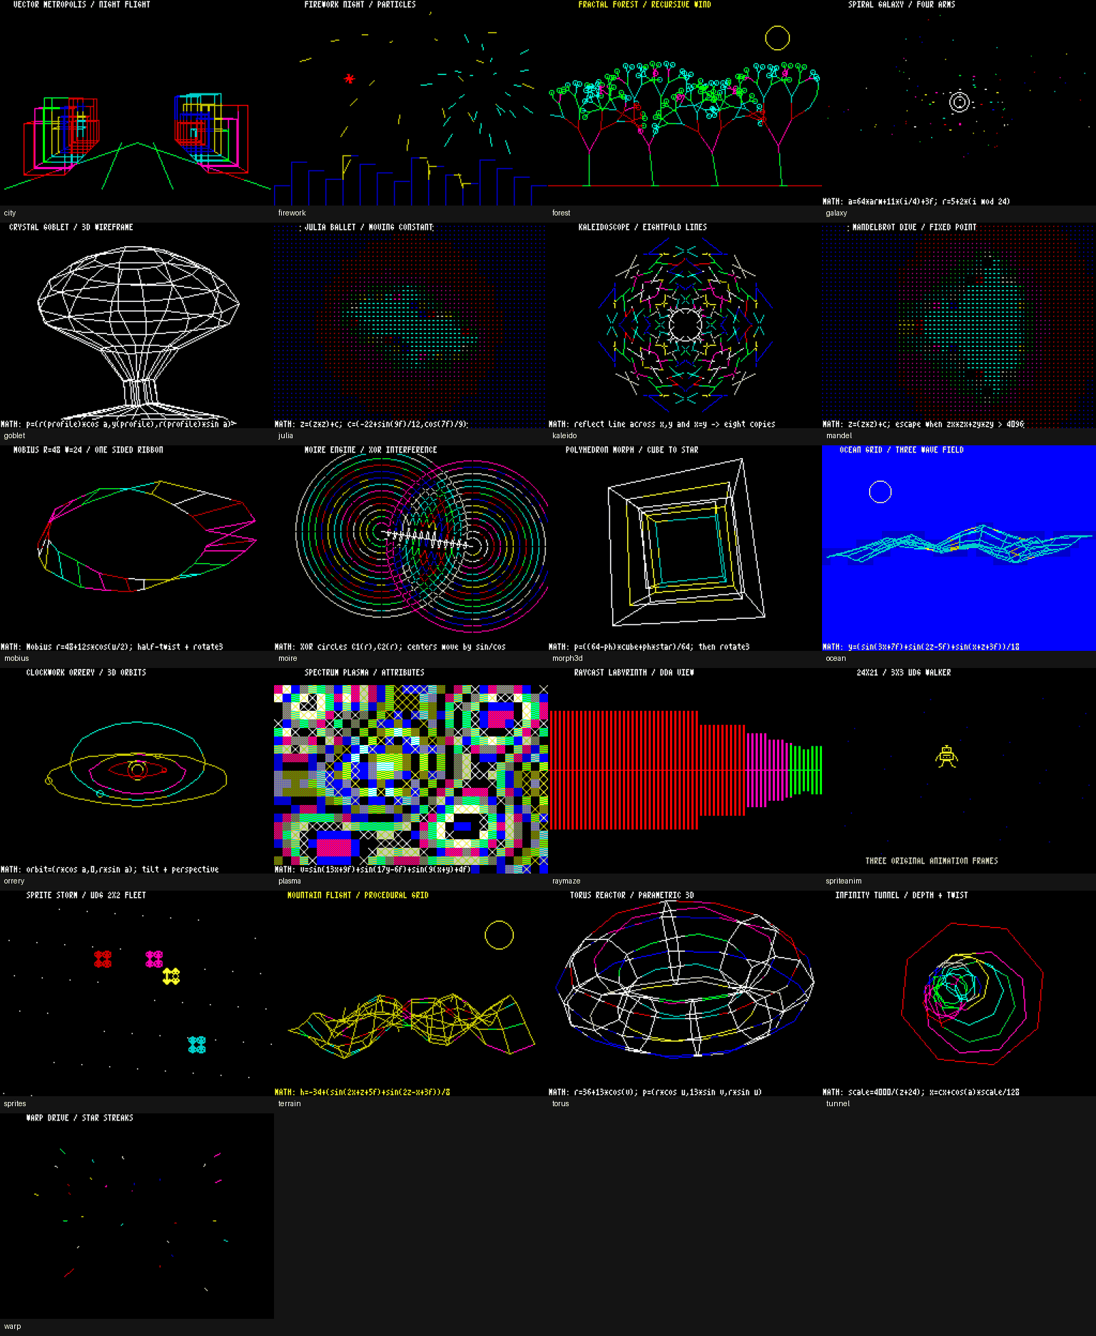
The graphics reel contains city, firework, forest, galaxy, goblet, julia, kaleido, mandel, mobius, moire, morph3d, ocean, orrery, plasma, raymaze, spriteanim, sprites, terrain, torus, tunnel, and warp.

11. Verification and Hostile-Input Safety
The compiler, preprocessor, C48B1 reader, and VM put clear bounds around hostile input. Parsers attract malformed data the way old carpet attracts mystery screws. Deep nesting, macro bombs, oversized executable data, and runaway VM work are bounded or rejected. The result should be a controlled error, not a Python traceback, hang, or host-memory feast.

11.1 What is bounded
Source-object bytes and translation-unit resource use.
Parser, constant-expression, semantic, and type/declarator depth.
Macro replacement growth and expanded preprocessing tokens.
C48B1 file bytes, JSON depth/container size, AST nodes, strings, and type depth.
VM user-function call depth.
Optional deterministic VM steps through --max-steps and wall-clock execution through --time-quota.
Bad input should end with a C48 diagnostic or a resource-limit error. It should not end with a Python traceback, hang, or host-memory blowup. Small attacks can be deceptive: a short nest of expressions or macros may demand a great deal of parser work.

11.2 Memory safety in the host VM
The adversarial tests cover one-past access, use-after-free, invalid free, double free, stale-pointer ABA reuse, raw pointer-byte forgery, and related range and lifetime errors. The host VM is stricter than bare shared RAM. Its job is to catch C48 misuse while we develop the program, not to recreate every ugly result of a bad pointer on real hardware.

11.3 Visible security fixtures
The SDK includes runnable security fixtures. They print ATTEMPT and MITIGATION on the 64-column screen before they exercise a guard. There is also a kernel-address source that is meant to fail compilation. The evidence is executable and visible, which is better than asking a paragraph to look trustworthy.

12. The Native ZX-UX Boundary
The C48 language contract is designed so canonical source can move unchanged between the host implementation and native ZX-UX, provided the source stays within the implementation resource limits of the target. That is a source-and-language portability contract. It is not a claim that C48B1 and MEX1 occupy memory in the same way.

12.1 Host success and native RAM fit
The current host VM does not calculate or reserve the complete native process footprint. A C48B1 program tree is a host object, not Z80 code in the 32 KiB arena. Python frames do not consume the native process stack. Host malloc() enforces a live-byte ceiling, while native crt0 reserves its heap in BSS. The host run also omits the resident shell and normal ZX-UX arena users. For those reasons, a successful c48run session is strong evidence for C48 language and modeled runtime behavior, but it is not a native-RAM-fit certificate.
Area | Host SDK 1.0.0 | Native ZX-UX target
Executable format | C48B1 typed host executable with integrity and schema checks. | OBJ1 modules are linked into MEX1 executables for Z80 execution.
Linking | One translation unit; no host multi-object C48B1 linker. | OBJ1 modules use the native ld linkage contract.
Header API | Same-directory SDK headers provide host-visible service declarations. | The native system interface is the compiler-resident <c48.h> contract.
Calling convention | C48 source semantics are modeled; host calls use Python frames and logical allocations. | C48_REGCALL defines Z80 register and stack placement.
Stack | Explicit VM call-depth protection; no byte-for-byte native stack reservation. | Normal MEX1 default stack is 512 bytes; -stack accepts even 64..4096.
Scheduler / syscalls | c48run is a host VM, not a ZX-UX kernel. | ZX-UX uses cooperative scheduling, process tables, pipes, cassette services, and kernel calls.
Float5 | Five-byte C48 float state with the default ROM-derived host math path. | The same five-byte C48 object representation is part of the target language/runtime contract.
Display | Exact 6912-byte screen state plus Tk/headless presentation and optional rendered images. | The real Spectrum supplies ULA contention, raster timing, interrupts, and physical display timing.
Native process footprint | C48B1 code/AST storage is host-side; C48 data objects use the 0x6000-0xDFFF logical arena. | MEX1 image+BSS, stack, ARG1/ENV1, heap reserve, and other process storage all consume the shared 0x6000-0xDFFF arena.
Heap accounting | Default is a 1,024-byte limit on simultaneously live malloc() payload bytes; storage is allocated on demand. | Normal crt0 reserves a 1,024-byte heap in BSS at link time; -heap accepts even 0..8192.
RAM-fit result | A successful host run does not prove the native process and resident system fit together in RAM. | Execution still depends on the native shared arena having enough space for the complete process and current system state.
The practical rule
Use the host SDK to write, compile, test, and harden C48 source. Treat a successful host run as a language/runtime check, not proof of native RAM fit. For the native machine, count the MEX1 image+BSS, stack, heap reserve, ARG1/ENV1, the resident shell, pinned resources, pipes, and other live arena objects. ZX-UX has 48 KiB of RAM and keeps excellent accounts.

13. Worked Example: Fractal Forest
Fractal Forest is the demo shown on the cover. It draws recursive trees, changes branch angle to create wind, uses Spectrum color, and yields each frame to the host presentation path. The full authoritative source appears in Appendix C.

13.1 Build and run
Host | Commands
Windows | c48.bat usr\src\demos\forest.c  c48run.bat usr\bin\demos\forest.c48b
Linux / macOS | ./c48 usr/src/demos/forest.c  ./c48run usr/bin/demos/forest.c48b

13.2 Capture the exact screen
./c48run --headless --dump-screen forest.scr usr/bin/demos/forest.c48b
forest.scr is the exact 6912-byte display state at program completion. It can be hashed, archived, compared, or rendered by tooling that understands the Spectrum bitmap and attributes. A .scr file is pleasantly literal; it contains the screen, not a biography of the screen.

13.3 What the example demonstrates
Direct C48 functions and recursion within the VM call-depth budget.
Integer arithmetic and fixed trigonometric helper values used by the demo API.
Spectrum drawing primitives, INK/PAPER, BRIGHT, circles, and positioned text.
Frame-by-frame yield() behavior.
Deterministic compilation from shipped source to the matching C48B1 path.

14. Troubleshooting
Symptom | Check
c48 or c48run does not start on Windows | Confirm Python 3.10+ is installed and python is on PATH. Run the .bat launcher from the SDK checkout.
./c48 or ./c48run does not start on Linux/macOS | Confirm Python 3.10+ is available as python3 and run the POSIX launcher from the checkout.
Graphical run fails but headless works | Tkinter or the host display environment is the likely boundary. Use --headless when no GUI is required.
Program appears to run forever | The program may contain an intentional or accidental infinite loop. For tests, add --max-steps N so failure is deterministic.
BEEP is silent on Linux/macOS | Install the optional playsound3==3.3.2 adapter if audible playback is required. Headless numerical sound verification does not need a physical speaker.
A stale or forged pointer fails in the VM | That is expected. The host runtime validates provenance, lifetime, range, alignment, and writeability.
An external C48 symbol is unresolved | The host SDK does not link another C48B1 module. Keep the required definition in the translation unit or use a documented host builtin.
A quoted include cannot be found | Check exact case, same-directory placement, portable basename rules, and .c/.h/.txt host proxy suffix.
A deeply nested or enormous input is rejected | The host safety ceilings are doing their job. They protect the compiler/runtime process from hostile resource use.
The GUI stays open after main returns | The final frame is intentionally held. Press Shift+Space to close it without changing the completed program status.

PART APPENDICES
QUICK REFERENCE
The pages we expect to open while the terminal is already busy.

Appendix A. Quick Command Card
Task | Command
Compiler version - Windows | c48.bat --version
Runtime version - Windows | c48run.bat --version
Compiler version - POSIX | ./c48 --version
Runtime version - POSIX | ./c48run --version
Compiler/about text | ./c48 --about
Runtime/about text | ./c48run --about
Compile shipped source | ./c48 usr/src/demos/forest.c
Compile to explicit path | ./c48 source.c -o out.c48b
Run graphically | ./c48run usr/bin/demos/forest.c48b
Run with C48 args | ./c48run usr/bin/examples/argv.c48b alpha beta gamma
Run headless | ./c48run --headless usr/bin/demos/forest.c48b
Dump screen | ./c48run --headless --dump-screen forest.scr usr/bin/demos/forest.c48b
Render paper PPM | ./c48run --headless --ppm forest.ppm usr/bin/demos/forest.c48b
Render framed PPM | ./c48run --headless --frame-ppm frame.ppm usr/bin/demos/forest.c48b
Request GUI scale | ./c48run --scale 2 usr/bin/demos/forest.c48b
Select font | ./c48run --font PATH usr/bin/demos/forest.c48b
Change host heap | ./c48run --heap 2048 usr/bin/demos/forest.c48b
Bound VM steps | ./c48run --max-steps 10000 usr/bin/demos/forest.c48b
Bound wall time | ./c48run --time-quota 5 usr/bin/demos/forest.c48b
Use host math approximation fallback | ./c48run --allow-approx-rom-math usr/bin/demos/forest.c48b
SDK verifier - Windows | python -B compiler\verify_release.py
SDK verifier - POSIX | python3 -B compiler/verify_release.py
Extended games - Windows | python -B compiler\verify_games.py --extended
Extended games - POSIX | python3 -B compiler/verify_games.py --extended

Appendix B. Specifications and Feature Card
Item | SDK 1.0.0 behavior
Host platforms | Windows, Linux, and macOS command-line workflow; Tk graphical frontend for interactive use.
Implementation | Python-based C48 host compiler and VM using the C48 16-bit data/address model and ZX-UX allocation range.
Compiler output | Deterministic C48B1 host executable, separate from native ZX-UX OBJ1/MEX1.
Translation units | One C48 translation unit at a time; no host multi-object linker.
Integer model | char 1 byte; short 2; int 2; pointer 2; plain char unsigned.
Float | 5-byte Spectrum-style representation with deterministic core arithmetic and ROM-derived transcendental path.
Pointer and allocation model | 16-bit target addresses; general C allocations are restricted to the ZX-UX 0x6000-0xDFFF 32 KiB arena. Native free space is lower because that arena is shared.
Display | 256x192 Spectrum model; exact 6912 bytes = 6144 bitmap + 768 attributes.
Text | 64x24 software text using packed 4x8 F4X8 font resources.
Graphics | INK, PAPER, BRIGHT, FLASH, OVER, INVERSE, plot/draw/circle, and UDG support.
Execution | Tk graphical frontend or deterministic headless execution; exact screen dump available.
Heap | 1024-byte default host ceiling; --heap accepts even 0..8192.
Safety | Explicit compiler/C48B1 resource budgets, VM call-depth protection, deterministic --max-steps, and optional wall-clock --time-quota.
Sound | Synchronous ROM-derived BEEP; Windows winsound; optional playsound3 on Linux/macOS.
Shipped program corpus | 3 applications, 14 games, 21 graphics demos, 6 basic examples, sound/security fixtures, and the AILMZX48 source/program tree.
Python dependencies | No third-party package for compiler or non-audio headless runtime.
Native RAM-fit certification | Not provided by c48run alone. Host and native share the 0x6000-0xDFFF allocation boundary, but code image, stack, heap reservation, and resident-system accounting differ.

Appendix C. Fractal Forest Source Listing
This listing is reproduced verbatim from the shipped usr/src/demos/forest.c source. If an installed SDK copy differs, the source in that SDK is the program to compile.
// ============================================================
// Copyright (c) 2026 Supratim Sanyal of SANYALnet Labs.
// Proprietary rights reserved except as licensed in LICENSE.
//
// ZX-UX C48 SDK - SANYALnet Labs Non-Commercial License.
// Non-commercial use permitted; Commercial Use and AI/ML
// model training prohibited unless separately authorized.
//
// Attribution required: Based on original work by Supratim
// Sanyal of SANYALnet Labs. See root LICENSE for full terms.
// ============================================================
#include "demoapi.h"
void clear_demo_rows(int first, int last)
{
int row;
ink(0);
bright(0);
over(0);
inverse(0);
for (row = first; row <= last; row++) {
print_at(row, 0, " ");
print_at(row, 32, " ");
}
}
void draw_labels(void)
{
paper(0);
ink(7);
bright(1);
over(0);
inverse(0);
print_at(0, 7, "FRACTAL FOREST / RECURSIVE WIND");
}
void branch(int x, int y, int len, int ang, int dep)
{
int nx;
int ny;
if (dep <= 0 || len < 3) return;
nx = x + d_cos(ang) * len / 128;
ny = y + d_sin(ang) * len / 128;
if (!d_ok(nx, ny)) return;
ink(2 + (dep & 3));
bright(dep < 3);
draw(x, y, nx, ny);
if (dep == 1) {
ink(4 + ((x + y) & 1));
circle(nx, ny, 2);
return;
}
branch(nx, ny, len * 3 / 4, ang + 18, dep - 1);
branch(nx, ny, len * 3 / 4, ang - 22, dep - 1);
}
void scene(int f)
{
int i;
int x;
int sway;
paper(0);
clear_demo_rows(1, 23);
ink(2);
bright(0);
draw(0, 18, 255, 18);
for (i = 0; i < 4; i++) {
x = 38 + i * 60;
sway = d_sin(f * 6 + i * 31) / 18;
branch(x, 18, 32 + (i & 1) * 6,
64 + sway, 6);
}
ink(6);
bright(1);
circle(214, 156, 11);
}
int main(int argc, char **argv)
{
int f;
int n;
paper(0);
cls();
draw_labels();
n = d_frames(argc, argv, 240);
for (f = 0; f < n; f++) {
scene(f);
yield();
}
return 0;
}

Appendix D. Documentation and Links
Use each document for the job it owns. That keeps a handy host feature from quietly turning into a native promise.
Document | Use it for
C48 Language Specification Rev 0.11 | Canonical C48 syntax, types, expressions, conversions, evaluation order, calling convention, and language limits.
ZX-UX Architecture Rev 12 | Native memory map, process model, OBJ1/MEX1, kernel/runtime services, console, graphics, UDGs, cassette, and target behavior.
ZX-UX C48 Compiler User Manual Rev 0.11 | Detailed compiler interface, diagnostics, native compiler/linker contract, runtime library, heap, stack, and portability guidance.
ZX-UX C48 SDK Technical Reference | Detailed host/runtime behavior, C48B1, memory and stack differences, Float5, display/input behavior, apps, games, demos, and verification boundaries.
ZX-UX C48 SDK Adversarial Security Review | Hostile-input findings, pointer/provenance checks, resource bounds, security fixtures, and remaining host-security limits.
The project repository is https://github.com/tuklusan/zx-ux-c48-sdk-sinclair-zx-spectrum-48k-unix-c-compiler-software-development-kit
The SANYALnet Labs / author blog is https://supratim-sanyal.blogspot.com/

END OF USER MANUAL

Native ZX-UX source tapes
The SDK distribution includes 57 native ZX-UX source tape images beside the matching frozen programs under usr/bin. Each .src.tap image carries the C48 program source and the local header needed by that program.
Each tape stores ZX-UX M48O version-1 RAW objects targeted at USERHOME. C source is type C (5); .h and .txt source material is type TXT (1). USERHOME resolves to the current /home/<user> when ZX-UX loads the object.
To use a tape, position or attach the .src.tap cassette at its start, load the header object first, then load the C object. For example, the hello tape is used as: load exapi.h, then load hello.c, then cc hello.c. Pass the emitted OBJ1 object to the native ld linker and run the resulting MEX1 program.
The native compiler-resident <c48.h> is supplied by ZX-UX itself and is not included on the source tapes. The model program is intentionally excluded because its present single-translation-unit form exceeds current native compiler resource limits.
The c48srctap host utility creates compatible source tapes. It accepts only lowercase .c, .h, and .txt inputs, validates names and text format, writes atomically, and performs an internal decode-and-compare check before success.

